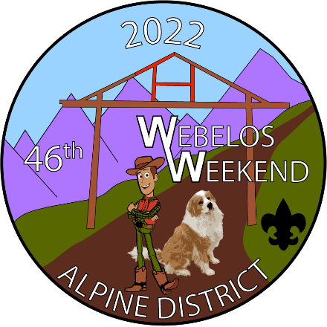
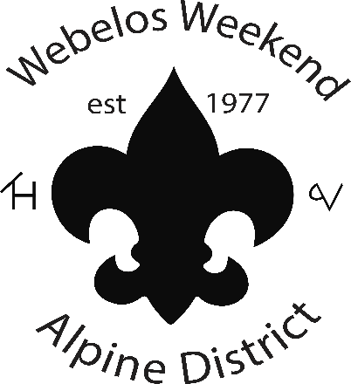
46th Webelos Weekend
hosted by Alpine District
at Camp Tahosa
STAFF
REGISTRATION
Webelos Weekend is in it’s 46th year and back home at Camp Tahosa!
Webelos Weekend is a two-night camping opportunity at Camp Tahosa for scouts entering their Webelos and Arrow of Light ranks. Webelos will practice the patrol method, learn skills for their rank advancements, and to learn what Scouting can be like after crossing over into a troop. Hint: more fun, new friends, more campouts, and more leadership.
BSA Troops: We are looking for Troops to staff skills stations please contact Scoutmaster Mrs. K. This year scouts staffing a station may be any age/rank with the approval of their Scoutmaster – except first year scouts.
BSA Scouts: We are looking for Patrol Leaders! You must be a minimum of First Class rank. Please contact Scoutmaster Mrs. K. Don’t forget to CC a parent for YPT.
If your troop has is registering to run a station, please be sure to select Station Staff, and if you’re registering as a Patrol Leader, please select patrol leader. When: June 3-5, 2022
Where: Camp Tahosa – 173 CO Rd 96, Ward, CO 80481
Who Should Attend: Scouts and Scouters looking to encourage the future of the program to continue in scouting.
Cost: $35 per staff
Questions: Contact Mrs. K, Sarah Krzanowsky (krzy8bear@gmail.com)

