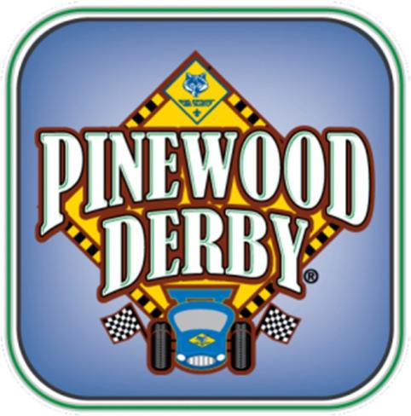**2024** **Black** **Feather** **District** **Pinewood** **Derby** **Championships** **Saturday April 6th**

**General** **Information** **and**

**the** **Official** **“Rules** **of** **the** **Road”**

This year’s District Derby will be held at St Andrews United Methodist Church

9203 S University Blvd, Highlands Ranch, CO, 80126

This event is a great enhancement to your Cub Scout Pack’s program. The entrance fee covers costs for patches, medals, and trophies for the event. All Cub Scouts must register and pay through Doubleknot, ~~<https://blackfeatherdistrict.doubleknot.com/event/2963839>~~ before the Scout is eligible to race.

**Eligibility**: All Cub Scouts are invited to bring this year’s Pinewood Derby Race Car. Lions, Tigers, Wolves, Bears, Webelos, and Arrow of Light will compete against their own grade level. Good luck and have fun!

Most importantly, please try to use the event as a recruiting opportunity for your Pack! New this year, **“Invite a Friend”**. Have your Cub Scoutinvite afriend andwe will have cars that they can “Adopt” for the PWD race. These cars will be available on a first come basis for the **“Friends”** to use on Race Day.

**VOLUNTEER** **REQUIREMENT**: It takes 80 volunteer hours on race day to run the District Derby. We will need help to make this a great event for our Packs and our District. Please plan to help.

**Register:** Cub Scouts on the District’s web site at: ~~[https://scoutingcolorado.org/districts/black-feather](https://scoutingcolorado.org/districts/black-feather/)~~[/](https://scoutingcolorado.org/districts/black-feather/)

**Volunteer:** Adults sign up for shifts at this link:  [https://www.signupgenius.com/go/10C0945AFA82BA7FFC43-48262619-2024]( https:/www.signupgenius.com/go/10C0945AFA82BA7FFC43-48262619-2024)

Sincerely,

*Heath Firestone*

Black Feather District Pinewood Derby

PWD@FirestoneStudios.com

**Please** **see** **the** **accompanying** **“Rules** **of** **the** **Road”** **for** **the** **Black** **Feather** **District** **Pinewood** **Derby!** **Only** **Cub** **Scouts** **officially** **registered** **with** **the** **Greater Colorado** **Council** **at** **the** **time** **of** **the** **District** **Pinewood** **Derby** **are** **eligible** **to** **race,** **as** **well** **as** **Arrow** **of** **Light** **Scouts** **who** **participated** **in** **their** **Pack** **Pinewood** **Derby** **and** **who** **are** **not** **registered** **in** **their** **Pack’s** **re-charter** **because** **they** **completed** **their** **Cub** **Scout** **journey** **earlier** **this** **year.** **The** **car** **entered** **in** **this** **championship** **must** **be** **the** **same** **car** **used** **in** **the** **Cubs** **most** **recent** **Pack** **Pinewood** **Derby** **unless** **the**

**car** **was** **built** **using** **a** **different** **set** **of** **rules** **than** **below.** **Youths’** **cars** **constructed** **for** **previous** **year’s** **competitions** **may** **not** **be** **used** **for** **this** **year’s** **race**. **A Scout is Trustworthy.**

**2024** **Black** **Feather** **District** **Pinewood** **Derby** **Championships** **Saturday** **April 6th 2023**

To participate, your car must fit within the rules given below. **Your** **Pack’s** **guidelines** **may** **have** **been** **different,** **so** **please** **check** **your** **car** **against** **the** **Official** **District** **“Rules** **of** **the** **Road”.** **If** **any** **given** **youth’s** **car** **does** **not** **qualify,** **you** **may** **take** **the** **opportunity** **to** **bring** **the** **car** **into** **compliance.**

There will be a small work area to make minor adjustments, but please make the proper measurements, ahead of time, to avoid disappointment. There will be a preliminary weigh-in scale at the race for you to check your weight before check-in with the official weigh-in scale. We will not be able to have a location site to lubricate your car, please do this outside the building before entering and before it is checked in. Once the car has been checked in, it will not be touched until race time and then only by race officials.

**Race** **Day** **Schedule** **–** **St Andrews United Methodist Church**

7:00 AM Track host volunteers arrive and begin track setup.

7:45 AM Check-in volunteers arrive and set up for Check-in.

8:15 AM Check-in for all Ranks (Cars will be weighed and inspected)

9:30 AM Invocation / National Anthem

9:45 AM Start of Races

12:00 PM Racing ends

12:05 PM Tabulation of Results

12:30 PM Trophy and Awards Presentation

Activities for youth will be available until races commence.

**VOLUNTEER** **NOTE:** **Volunteer** **shifts** **are 60-90** **minutes** **and** **do** **not** **correspond** **exactly** **with** **race** **times** **above.** **It’s** **a** **great** **idea** **to** **partner** **with** **another** **parent,** **so** **each** **of** **you** **can** **see** **your** **Cubbies race!**

**Volunteer:** Adults sign up for shifts at this link:

**Black** **Feather** **District** **Pinewood** **Derby** **Rules** **of** **the** **Road** (Ver. 01082024)

While there are many web sites and other resources that discuss Pinewood Derby designs, and while many Packs have their own rules, the following rules are established for the **Black** **Feather** **District** Finals Race, and in fairness to all participants, cars that cannot conform to these specifications will not be allowed to race.

These requirements provide assurance that the car meets dimensional requirements ensuring the car can race without obstruction or interference to other racecars on the track, and to ensure the race remains fair across all competitors.

Prior to the race or prior to the end of the established check-in period, any participant’s vehicle that does not meet the following requirements can be modified in an attempt to meet the specified requirements.

# Dimensional Requirements:

The car dimensional requirements are set with respect to the dimensions of the racetrack being utilized by the Black Feather District for this race.

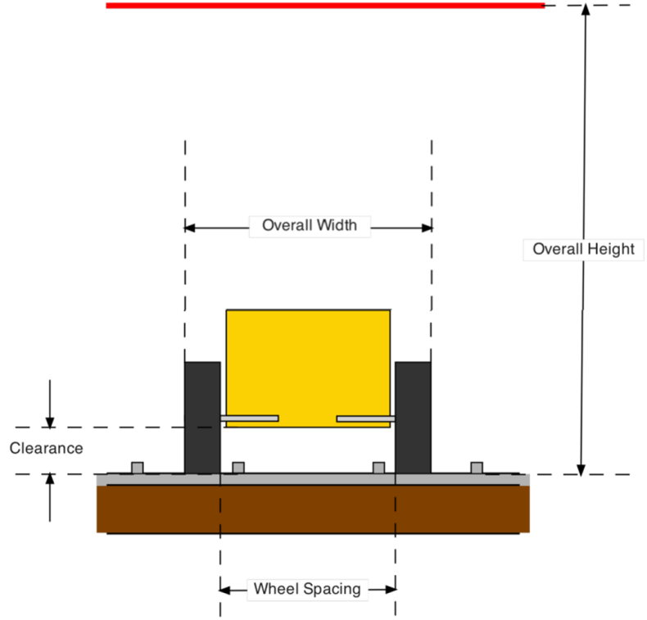

3 1

Wheelbase: = 4 8 " ± 16 " (Distance between the front and rear axles) Overall Width: ≤ 2.75”

Overall Length: ≤ 7.0” Overall Height: ≤ 5.0” Clearance: ≥ 0.25” Wheel Spacing: ≥ 1.75”

Weight: ≤ 5.00 ounces (relative to official race scale)

# Fair Competition Requirements:

The criterion for fairness is set forth by the Black Feather District Committee and includes these restrictions:

1. Cars constructed for prior year District competitions may not be used for this year’s race.
2. All cars must be constructed from the Official Cub Scout Grand Prix Pinewood Derby Kit. A car kit includes a

1.75” wide x 1.25” high x 7” long block of pinewood with an axle spacing of 4 3/8”. It includes four nail axles and four wheels. It is okay to augment the body of the car with aftermarket accoutrements such as weights and decorative additions such as engines, exhaust pipes, fenders, windows, and other decorations. All of these accoutrements must be firmly affixed to the vehicle.

1. Axle spacing must not be altered. The axle spacing set forth by the Official Cub Scout Pinewood Derby Car Kit is 4 3/8”.
2. The construction of the cars must not include aftermarket axles or wheels. Examples include single axles or precision-machined pins in place of the four nail axles that came with the kit. It is okay to modify the nail axles to improve performance. These modifications can include but are not limited to polishing, removing ridges, or removing material, and axle bending. The construction of the car must allow for inspection to verify use of these kit materials. The ends of each axle nail must remain visible.

Note: It is allowable to have only three (3) wheels touching the track, commonly referred to as a “lazy wheel”.

Note: Bent axles are allowed assuming they are using nails that came with the kit.

1. A car must not utilize bushings, washers, wheel bearings, axle bearings, or a suspension system of any kind. The materials for movement are limited to the official wheels, official axle nails, and dry lubricant.
2. A car must not include any motive forces such as springs or electrical or mechanical drive mechanisms. The force of gravy must be the sole force that acts to propel the car down the track.
3. At the starting gate, the car is retained by a starting pin located in the front and center of the car. No mechanical feature of the car can protrude beyond the uphill edge of the starting pin. Examples of this are cars with a V-cut feature for the front, or protruding aspects such as a gun barrel on a tank.
4. Wheel modifications are strictly limited to the removal of the wheel’s mold seam on the tread to create a flat and even surface for the wheel to ride upon the track and minimal outside rounding, with outside diameter to be no less than 29.9 mm. The wheel’s track contact surface cannot be rounded, grooved, ridged, or reduced in width with the purpose of limiting the amount of wheel contact area riding upon the track. The wheels must not be machined so as to reduce the mass of the wheel such as reducing the thickness of the wheel material, except fort he purpose of making the wheel round on the outside.

Note: Lightweight wheels are not allowed. Minimum thickness of the wheel is 1.4mm with 29.9 mm minimum outside wheel diameter checked with a caliper. No lathing of the inside of the tread/wheel.

1. Wheels may be subject to precision measurement at check-in.
   * Wheels must have at least 7.5 mm minimum tread width.
   * Minimum wheel diameter 29.9 mm
   * Minimum wheel thickness 1.4 mm
   * BSA lettering must remain visible on the inside and outside of the wheels.
   * Tread/contact service must remain flat to the bore.
   * Wheels must be across from each other.
   * Nothing can be on the axle (touching it) between the wheel and the car body.
2. All wheels that ride upon the track must be freewheeling.
3. All car finishes (such as paint or clear finishes) must be contact dry (not wet or tacky). Verify the car does not use wet lubricants. If lubrication is present, it must be a dry lubricant such as graphite powder.
4. Cars must have a designated front and rear. If the car’s front and rear are not obvious, then before or during check-in, the participant must mark the car to indicate the front and rear. All cars will be raced with the front first.

During check-in, each car will be inspected for compliance with these above criteria. Any cars not meeting these criteria will be disqualified. Participants can make any necessary modification, as possible, to achieve a successful check-in. At the completion of the check-in period, additional cars will not be accepted. All cars that pass check-in inspections are accepted and retained by the race officials until completion of the race. All cars that are accepted at check-in will not be re-evaluated to meet check-in criteria. No participant or race official can challenge a car that has been accepted – no exceptions. Due diligence will be performed to ensure a fair race and good sportsmanship will prevail.

# General Information:

1. The track is 48 feet long, with a raised center that is 1 5/8" wide and 1/8" thick running down the center of each lane to keep the car in its respective lane. The starting gate has a slightly wider lathe, so the cars are accurately centered in the lane. It is very important not to reduce the width of the wood block where the wheel and axle are attached to the car body. If wood is removed from this area, the wheels may rub on the center lath and slow the car.

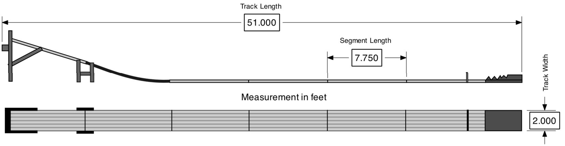

1. Pinewood Derby cars are approximately 1/24 scale, and many decals and accessories are available at local hobby stores in this scale. In addition, there are decal sets and plastic drivers available at The Council Scout Shop (10455 West 6th Avenue, Suite 125, Denver, CO 80215 303-477-4830).
2. A car that jumps the track or interferes with another car will cause the Race Officials to pause the race and determine the cause of the problem. If debris on the track caused the car to jump out of the lane, the debris will be removed, the track will be wiped down/cleaned quickly, and the heat will be re-run with the cars in their same lanes. If Race Officials determine that the car’s design or performance caused it to jump the track, Race Officials will determine whether the problem can be adjusted or repaired within 5 minutes, and the Scout/Racer will be given all reasonable opportunity to repair the car and continue racing. The heat will then be re-run with the cars in the same lanes. If the car jumps the track following the rework or repair, the car will not be rerun, and it will lose the heat. If the race officials rule the car cannot be fixed, then the car will be removed from the competition and a dummy car will be run in its place.
3. Within reason, and to be decided by Race Officials, if a car experiences breakage during a race, the Scout and parent may be allowed a quick (up to 5 minutes) repair of the car to enable the Scout’s continued participation. Officials will then run that heat again. If the car cannot be repaired within 5 minutes, it loses the heat.
4. After check-in, race officials will hold the racecar until after race time. No alterations will be allowed after the car is checked in. The weight at check-in will be official. Identification numbers will be furnished at check-in. The inspection team has the right to disqualify those cars which do not meet official specifications. Graphite powder will be available to everyone on race day for use prior to check in. Following check-in, no re-lubrication will be allowed.
5. If a car does not make it to the finish line, the car will be picked up and it will register a max time for that heat. Except for cars that have mechanical problems, no car will be allowed to be removed from the race until the race is complete. Between races, a Scout/Racer can elect to withdraw from the competition for any reason. Additionally, race officials can remove a car from the competition between races for unsportsmanlike conduct.

**GOOD** **SPORTSMANSHIP** **AND** **BEHAVIOR** **ARE** **EXPECTED** **FROM** **SCOUTS** **AND** **PARENTS.** Race Officials may ask anyone not following this rule to leave. Alternatively, race officials have been known to publicly honor good sportsmanship among competitors as observed by the officials.